Features
- Direction sensor is used to find out hand movement so that robot can move in all fore direction
- Direction sensor generate two code for each direction and then these code is encoded at transmitter and then transmiited
- recevied code at ther receiver is decoed into bit pattern which given to Motor drver IC which control the motor and Robot can function
- Distance is upto 300mts
- Robot can be controlled with mouse , keyboard , Palm(hand) and voice
- interactive User Interface is designed in VB

Introduction
Robotics is a fascinating subject more so, if you have to fabricate a robot yourself. The field of robotics encompasses a mini her of engineering disciplines such as electronics (including electrical), structural, pneumatics and mechanical.
The structural part involves use of frames, beams, linkages, axles, etc. The mechanical parts/accessories comprise various types of gears (spurs, crowns, bevels, worms and differential gear systems), pulleys and belts, drive systems (differentials, castors, wheels and steering), etc. Pneumatics plays a vital role in generating specific pushing and pulling movements such as those simulating arms or leg movements. Pneumatic grippers are also used with advantage in robotics because of their simplicity and cost-effectiveness. The electrical items include DC and step per motors, actuators, electrical grips, clutches and their control. The electronics part involves remote control, sensors (touch sensor, light sensor, collision sensor, etc), their interface circuitry and a microcontroller for over all control function.

Project Overview
Project overview
What we present here is an elementary robotic land rover that can be controlled remotely using primarily the RF mode. The RE remote control has the advantage of adequate range (up to 200 meters with proper antenna) besides being omni directional. On the other hand, an ER remote would function over a limited range of about 5metres and the remote transmitter has to be oriented towards the receiver module quite precisely. However, the cost involved in using RE modules is much higher than of IR components and as such, we have included the re placement alternative of RF modules with their IR counterparts for using the IR remote control.
The proposed land rover can move in forward, and reverse directions. You would also be able to steer it towards left and right directions. While being turned to left or right, the corresponding blinking LEDs would blink to indicate the direction of its turning. Similarly, during reverse movement, reversing LEDs would be lit. Front and rear bumpers are provided using long operating lever of micro switches to switch off the drive motors during any collision.
The decoder being used for the project has latched outputs and as such you do not have to keep the buttons on remote control pressed for more than a few milliseconds. This helps prolong the battery life for remote.
Forward and reverse movement
To keep our design as simple as possible, we have coupled a 30-rpm geared 6V DC motor to the left front wheel and another identical motor to the right front wheel. Both these front motors are mounted side-by-side facing in opposite directions. Wheel rims (5cm diameter) along with rubber wheels are directly coupled to each of the motor shafts, This arrangement does not require separate axles.
During forward (or reverse) movement of the vehicle, the two wheel shafts, as viewed from the motor ends, would move in opposite directions (one clockwise and the other anticlockwise). For reversing the direction (forward and backward), you simply have to reverse the DC supply polarity of the two motors driving the respective wheels.
Steering control
There are different methods available for steering a robotic vehicle. The commonly used ones are:
1. Front wheels are used for steering, while rear wheels are used for driving; e.g. in tractors.
2. Front wheels are used for steering as well as driving; e.g., in most light vehicles. In these vehicles (such as cars), the front wheels are coupled using a differential gear arrangement. It comes into play only when one wheel needs to rotate differentially with respect to its counter part. When the car is moving in a straight line, the differential gears do not rotate with respect to their axes. However, when the car negotiates a turn, the differential allows the two wheels to rotate differentially with respect to each other.
3. All the four wheels are used for driving as well as steering. Examples are Kyosho (USA) 4-wheel drive/4- wheel steering elect powered monster truck chassis.
4. Single front wheel is used for driving as well as steering; e.g., in a tricycle.
5. Two driving wheels that are in dependently controlled to turn; e.g., in a tank.
In our project, to keep the things simple, we have used Method-5 with some modification. For the rear wheels, we have made use of a single. plastic castor wheel, identical to the ones used in revolving chairs. Such a wheel turns by 180⁰ when you try to reverse the direction of the vehicle’s motion. This way the movement of the rover become stable in both the for ward and reverse directions. The steering (clockwise or anticlockwise) motion is achieved by driving only one wheel at a time. To turn the vehicle towards left (as perceived by the driver) we energies only the right- hand-side motor, and to turn it towards right we energies only the left- hand-side motor during turning.
The movement is controlled with the help if the tilt sensor which generates the different bit patterns as discussed in Tilt Sensor Topic.

Transmitter
Transmitter
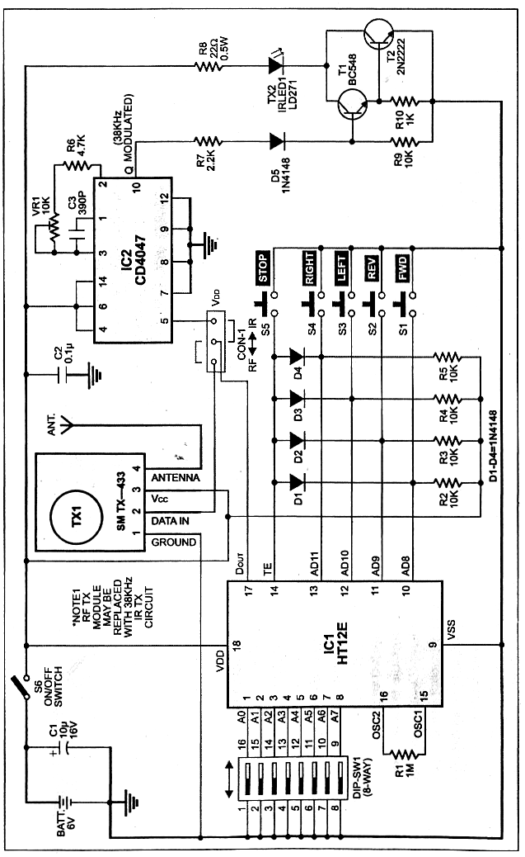

4 Direction Tilt Sensor and Decoder IC
RF transmitter and RF receiver
The RF transmitter arid receiver modules marketed by Aplus India, Mumbai have been employed for RF remote control. The RF transmitter TX-433 is an AM/ASIC transmitter. Its features include:
1. 5V-12V single supply operation
2. On-off-keying (OOK)/amplitude shift keying (ASK) data format
3. Up to 9.6kbps data rate
4. +9dBm output power (about 200m range)
5. SAW-based architecture
6. For antenna, a 45cm wire is adequate.
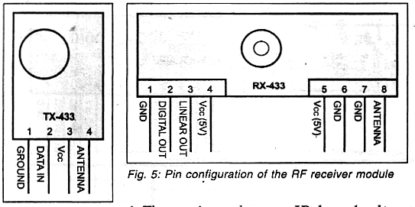

The output power and current drain of the HF transmitter for Vcc of 5V and 12V are tabulated in Table IV.
The pin configuration of the transmitter module is shown in Fig. 4. The RF receiver RX-433 is a 433MHz module. Its pin configuration is shown in Fig. 5 and technical specifications are given in Table V.
Remote transmitter.
A complete schematic of the remote control transmitter-encoder circuit is shown in Fig.
The receiver address to be transmitted can be set with the help of 8 way DIP switch DIP-SW2.
When any switch is open the pin connected to that switch is at logic 1, and when it is closed the respective pin is at logic ‘0.’ The data pins are pulled high via resistors R2 through R5. In this condition if TE pin is taken low (by depressing STOP switch) the binary data transmitted via pins AD8 through AD11 will be ‘1111’ (decimal 15). When any other data pin marked FWD, REV, LEFT or RIGHT alone is pressed, a ‘0’ will be sent at that data position, while other data pins will represent logic ‘1’ state. The logic circuitry at the receiver- decoder end will decode the data appropriately for controlling the two motors of the land rover.
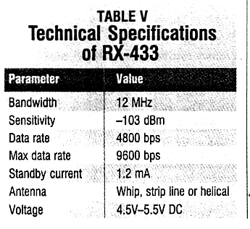
IR based alternative.

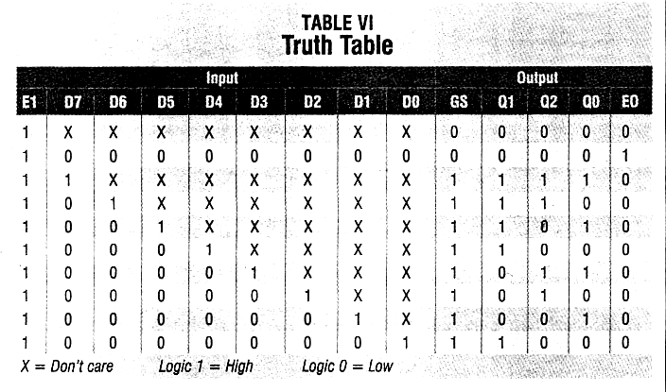
The RF modulator used in the remote can be easily replaced with the IR modulator circuit built around IC2 and transistor T1. The RF/IR selection can be affected by moving the shorting link of Con-1 connector. Similarly, the RF receiver module in the RF receiver-decoder can be replaced with them receiver module shown in Fig. .
For using the IR-based encoder, the DOUT signal pin (pin 17) of HT12E is to be connected to DIN pin 5 of astable oscillator IC CD4047 for modulating its output. The frequency of the astable at output pin 10 is determined by the timing components as follows:
1
Frequency 4.71x(R6+VR1)xC3 Hz
This frequency is adjusted for 38 kHz with pin 5 held at logic 1. The modulated 38 kHz, after amplification by Darlington pair of transistors T1 and T2, drives IRLED LD271 (or equivalent).

Receiver
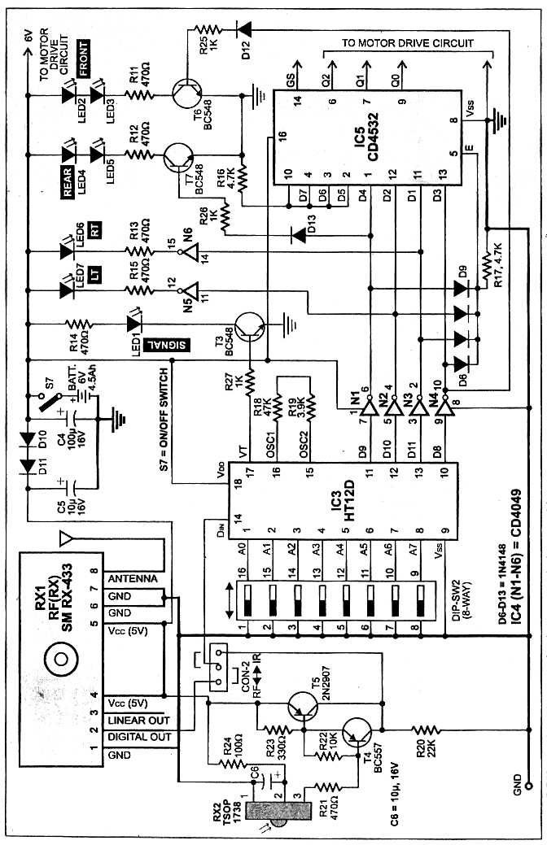
Receiver
RF receiver-decoder.
The complete RF receiver-decoder circuit employing HT12D is shown in Fig. 7. Assuming that identical address is selected on the encoder and the decoder, when any of the switches on the transmitter (marked as FWD, REV, RIGHT, LEFT) is depressed, the corresponding datapin of the demodulator will go low. The data outputs of HT12I) are fed to 8-bit priority encoder CD4532 via inverters to generate appropriate logic outputs in conformity with Table III to control the left-/right motors for required motion of the land rover as explained earlier.However, when STOP button is pressed on the remote transmitter, all data pins (D8 through D11 on the decoder will latch to the high output state. After inversion by NAND gates N1 through N4, all the outputs will be low and hence EI (pin 5) of CD4532 will go low to force all its outputs to go low. As a result, both the motors will stop running.
You may like to verify the code generated at the outputs of CD4532 with the help of truth table (refer Table VI). The following is the exact sequence of operation at the receiver (Fig.) and the motor driver (Fig.) when a specific push switch is momentarily pressed on the transmitter:
Forward
The D8 output (pin 10) of IC3 goes low which after in version by inverter N1 goes high to switch on the front LEDs (LED2 and LED3) via driver transistor T6 and take D3 input (pin 13) of IC5 high. This causes Q2, Q1 and Q0 going to logic states ‘0’,’l’ and ‘1,’ respectively (as per Table VI), and as a result, both the motors will run in such directions as to move the rover in forward direction.
Reverse.
The D9 output (pin 11) of IC3 goes low, which after inversion by inverter N2 goes high to switch on the rear LEDs (LED4 and LED5) via driver transistor T7 and take D4 input (pin 1) of IC5 high. This results in Q2, Q1 and Q0 going to logic states ‘1, ‘0’ and ‘0,’ respectively (as per Table VI), and as a result, both the motors will run in such directions as to move the rover in reverse (backward) direction.
Left.
The D1 output (pin 12) of 1C3 goes low, which after inversion by inverter N3 goes high to switch on the left blinking LED7 after a second inversion by inverter/driver gate N6 and makes D2 input (pin 12) of IC5 high. This results in Q2, Q1 and Q0 going to logic states ‘0,’ 1’ and ‘0,’ respectively (as per Table V and as a result, only the right-hand-side motor will run and the left-hand-side motor will be static, This causes the rover to perform a left turn.
Right.
The D11 output (pin 13) of IC3 goes low, which after inversion by inverter N3 goes high to switch on the right blinking LED6 after a second inversion by inverter/driver gate N5 and makes Dl input (pin 11) of IC5high. This results in Q2, Q1 and Q0 going to logic states ‘0’,’0’ and 1/ respectively (as per Table VI) and as a result, only the left-hand-side motor will run and the right-hand-side motor will be static. This causes the rover to perform a right turn.
5. Stop. The D8 through D11 out puts of IC3 go high and, after inversion by inverters N1 through N4, cause blocking of diodes D5 through D8. As a result, ground is extended to EI pin 5 through resistor R17 and all the out puts (Q2, Q1 and Q0) of CD4532 go low to stop both the motors. All the LEDs also stop glowing.

